Files in Linux

# Project description

In this scenario, the analyst team tasked me to execute some organizational tasks. The following are as follows:

1. Find and search les
2. Create and remove a directory
3. Move and remove a le
4. Create and edit a le

The operating system is Linux, indicating that the tasks require a command-line interface (Linux Bash shell) approach via Linux Terminal.

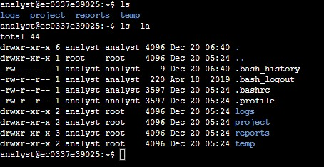

# Find and search les

The analyst team asked me to locate a log le whose lines contain the text string error. The le is server_logs.txt.within the directory logs. We can examine the actual lines within the le by using cat server_logs.txt a er cd logs / cat

/home/analyst/logs/server_logs.txt command. The image below shows the entire lines of the text.

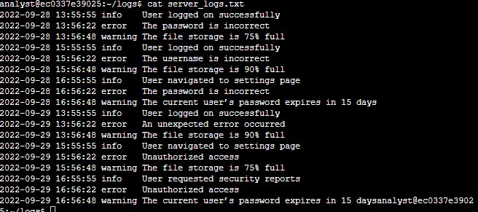

Now, let’s lter this le so it will return a list of the lines that match the text string “error” in that le. The command grep error server_logs.txt will make it happen. As the result shows below, there are six lines that match the text string “error”.

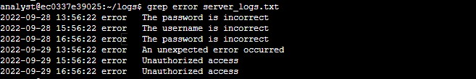

The analyst team also would like me to locate les whose names contain Q1 and access within the users directory. First, let’s write the command cd /home/analyst/reports/users to enter users directory and ls /ls -la commands to view all the les within the directory.

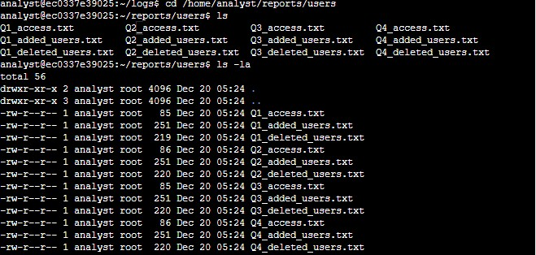

This command (grep) will allow us to nd the les whose names contain Q1:

ls | grep Q1 (make sure you’re already in the directory) or ls

/home/analyst/reports/users | grep Q1. There are three les associated with Q1.



Using the same logic, we can locate a le whose name contains access: ls | grep access (make sure you’re already in the directory) or ls

/home/analyst/reports/users | grep access As the result shows, there are four les associated with access.

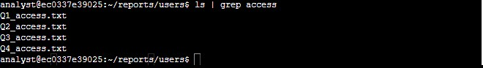

Last but not least, the analyst team would like to search information contained in user les and report on users that were added and deleted from the system. They would like to search the Q2_deleted_users.txt le within the users directory for the username jhill. As the result shows, we found jhill in this le. grep jhill Q2_deleted_users.txt



To see whose people have been added to the Human Resources department, we can use grep command. For more than one word, we should use “” to execute the command.

grep "Human Resources" Q4_added_users.txt

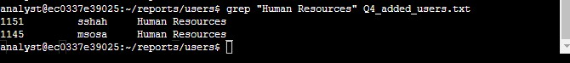

# Create and remove a directory

The analyst team would like me to create a new directory named logs and remove temp directory from the system. Here’s the command line to create and remove directory:

mkdir logs (create)

rmdir temp (remove)



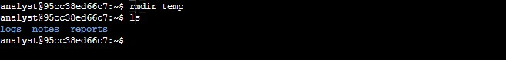

# Move and remove a le

The team would like to move Q3patches.txt le to another directory. In the Notes directory

(please navigate here), the command mv Q3patches.txt /home/analyst/report will move the le to the notes directory.

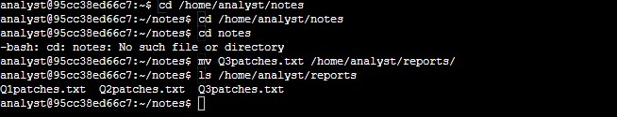

The team would like me to remove tempnotes as it is no longer required in the notes directory. The command rm tempnotes.txt will allow us to delete it (please make sure to use cd command to navigate to notes directory).



# Create and edit a le

The analyst team would like me to create a new le and edit it. The command touch tasks.txt allows us to create a le. On the other hand, the command nano tasks.txt allows us to edit a le. Make sure to press CTRL + X to exit from the nano editor. When being asked “Save modi ed bu erer”, press Y to save the new data to the le. Then, please press enter to con rm that the le name to write is tasks.txt. Use cat tasks.txt command to display the contents of the tasks.txt.

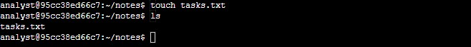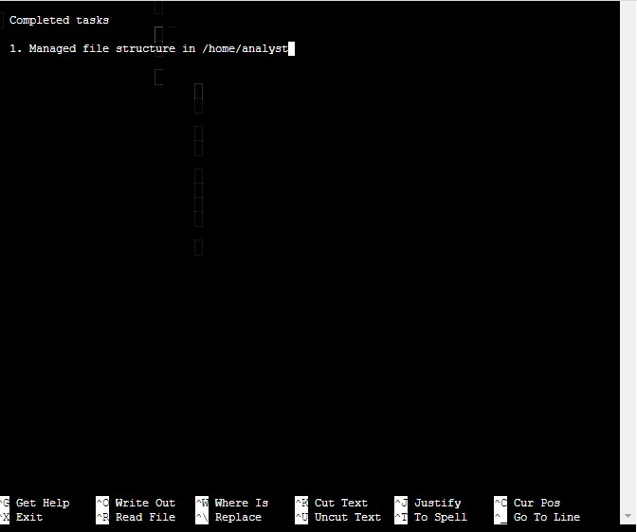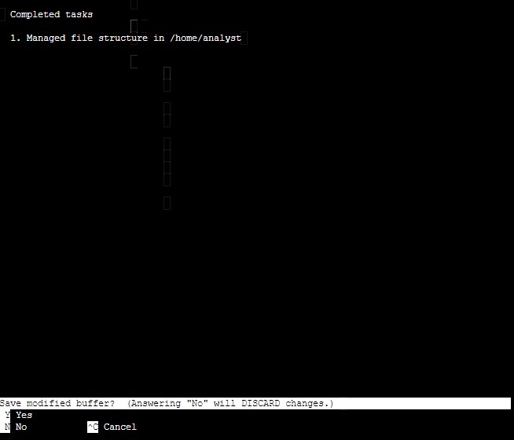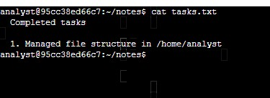

# Summary

Here, I successfully found and searched les, created and removed a directory, moved and removed a le, and created and edited a le on Linux Terminal.